汉字练习

- Color the specific stroke as required in each of the characters.
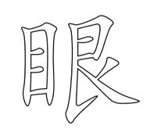 | 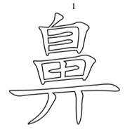 | 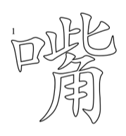
6th stroke | 8th stroke | 10th stroke

- Add and/or subtract strokes
(Example: 大＋3－小＝ 3)
眼＋10－目＋3＝

脸＋7－耳＋5=

- Play character puzzles.
Preparation: print characters on 8x11 paper, one character per paper. Cut the character in 7 pieces. Students need to put the 7 pieces back to form the character.

- Arrange characters by numbers of strokes from the character with least stroke to the one with the most stroke number.
(照笔画数多少排顺序：算笔画，然后按照笔画数排列，从最少排到最多。)
口 耳 目 自 鼻 脸 腿 眼 嘴

- Circle the incorrect characters in the sentences.
我有一张园园的脸，一又大大的眼睛，和一个高高的自子。

- Play the PPT game “Passcode.”
Use the PPT in (phase2 activity3 passcode).

- Make character cloud.
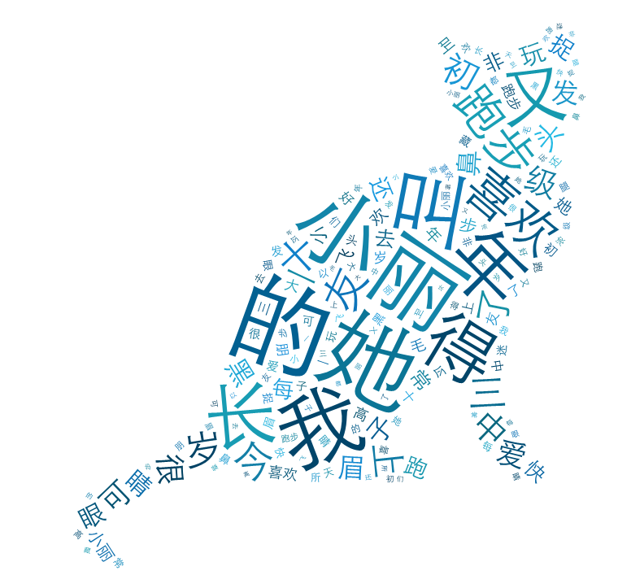
Create a word cloud:
- Go to www.tagxedo.com to create a simple word cloud.
- Click on create, then load, and type in the text and then submit.
- If unsure how to create a word cloud, watch a tagxedo tutorial at http://youtu.be/AwuB7Ub9RQU.

Use the word cloud:
- Show the word cloud, demonstrated above (a cat shape), to students.
- Give students two minutes to look at the Tagxedo image.
- Divide students in pairs. Give each pair a minute to recall and discuss what characters are included in the word cloud.
- The teacher calls on students to say the characters they read.

- Combine components to form characters

Provide students the components, such as退、又、 月、欠 and students have to form the characters腿 and欢.

- Character reading practice
Divide students in pairs. The student in each pair takes turn reading the characters and keeps the record (see the character-reading chart and the record chart form on next page).
